Revised Classification Report for CNN – Deep Learning

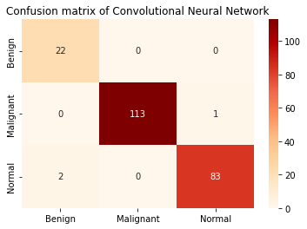

Figure: Revised Confusion matrix of CNN using raw data

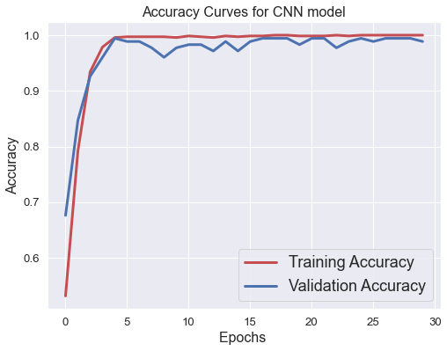

Figure: Revised Accuracy Curve of CNN Model

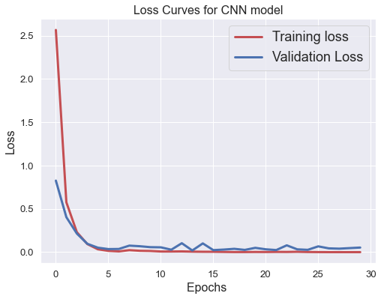

Figure: Revised Loss Curve for CNN Model

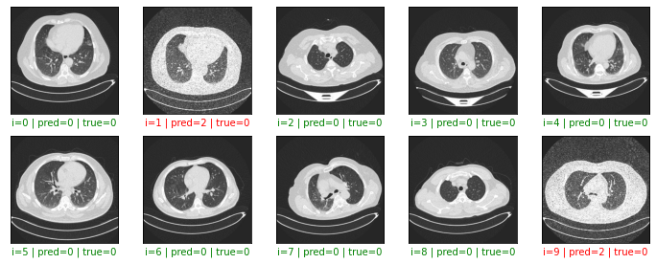

Figure: Revised few of the predicted results using CNN

Revised Table – 2

|  |  |
| --- | --- |
| Evaluation  Parameters | Preprocessed  raw data |
| Training Accuracy | 100% |
| Test Accuracy | 98.64% |
| Training Loss | 0.0001 |
| Test Loss | 0.053 |
| Precision | 0.987 |
| Recall | 0.986 |
| F1 Score | 0.986 |

Table 2: Accuracy score of CNN with preprocessed dataset and the TL features

c) Why vgg16 when there are better and lighter alternatives?

VGG-16 has an exceptional feature extraction capability, allowing us to utilize it in our research for feature extraction. It has a greater capacity to learn new features because it is deeper than certain transfer learning models, such as AlexNet. VGG-16 uses just 3×3 convolution layers and 2×2 pooling layers repeatedly, which makes it significantly less complex than other Transfer Learning models like InceptionNet and enables it to generalize more effectively and adapt to a larger variety of data sets, including tumor images.

d) Probably there is no need to include all proposed ML alternatives.

All of those algorithms were selected since they all perform excellently and over 90%. We wish to present the comparative results so that readers may compare all of the methods. It is difficult to choose which one to keep and which one to discard because they all function so well.